**1. Write a program to find the root of non-linear equation using Bisection method.**

//Bisection Method

#include<stdio.h>

#include<conio.h>

#include<math.h>

#define MAX 20

#define E 0.00001

#define f(x) (x*x-4*x-10)

int main()

{ int count=0;

float x1,x2,x0;

printf("Enter the inital guess values x1 and x2\n");

scanf("%f%f",&x1,&x2);

if(f(x1)*f(x2)>0)

printf("The guess values don\'t bracket root. Change the guess values.");

else

{ begin:

x0=(x1+x2)/2;

if(fabs(f(x0))<E)

{

printf("\nThe root is %f",x0);

printf("\nNo. of iterations is %d",count);

}

else{

if(f(x0)>0){

x2=x0;

count++;}

else if(f(x0)<0){

x1=x0;

count++;}

if (count<MAX)goto begin;

else printf("\nThe process doesn\'t converge.");

}

}

return 0;

}

**Output:**

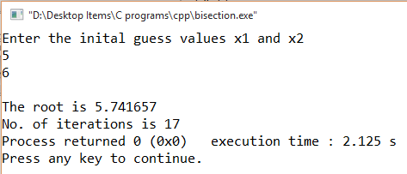

**2. Write a program to find the root of non-linear equation using Newton Raphson method.**

//Newton Raphson Method

#include<stdio.h>

#include<conio.h>

#include<math.h>

#define MAX 20

#define E 0.0001

#define f(x) (exp(x)-x-2)

#define f1(x) (exp(x)-1)

int main()

{ int count=1;

float x0,x1;

printf("Enter the initial guess value. ");

scanf("%f",&x0);

if(f1(x0)==0)

printf("Derivative is zero at guess value.");

else

{ begin:

x1=x0-(f(x0)/f1(x0));

if(fabs((x1-x0)/x1)<E)

{

printf("The root is %f",x1);

printf("\nNo. of iterations is %d",count);

}

else

{

x0=x1;

count++;

if(count<MAX) goto begin;

else

printf("The process doesn\'t converge.");

}

}

return 0;

}

**Output:**

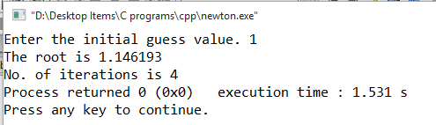

**3. Write a program to find the root of non-linear equation using Secant method.**

//Secant Method

#include<stdio.h>

#include<conio.h>

#include<math.h>

#define MAX 20

#define E 0.0001

#define f(x) (exp(x)-x-2)

int main()

{ int count=1;

float x1,x2,x3,f1,f2;

printf("Enter two initial guess values. ");

scanf("%f%f",&x1,&x2);

begin:

f1=f(x1),f2=f(x2);

x3=x2-f2*(x2-x1)/(f2-f1);

if(fabs((x3-x2)/x3)<E)

{

printf("The root is %f",x3);

printf("\nNo. of iterations is %d",count);

}

else

{

x1=x2;

f1=f2;

x2=x3;

count++;

if(count<MAX) goto begin;

else

printf("The process doesn\'t converge.");

}

return 0;

}

**Output:**

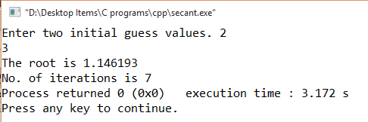

**4. Write a program to find the root of the non-linear equation using Fixed Point method.**

//Fixed point method

#include<stdio.h>

#include<conio.h>

#include<math.h>

#define MAX 20

#define E 0.0001

#define g(x) (exp(x)-2) //exp(x)-x-2=0, x=exp(x)-2

int main()

{ int count=1;

float x0,x1,error;

printf("Enter the initial guess value. ");

scanf("%f",&x0);

begin:

x1=g(x0), error=x1-x0;

if(fabs(error)<E)

{

printf("The root is %f",x1);

printf("\nNo. of iterations is %d",count);

}

else

{

x0=x1;

count++;

if(count<MAX) goto begin;

else

printf("The process doesn\'t converge.");

}

return 0;

}

**Output:**

